**P1 – Explain the different types of animation**

**Introduction**

In this report, I will explain the definition of animation and traditional animation with an example. I will also the computer animation techniques too.

**Animation**

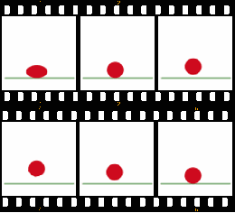Animation is simply a display of moving images. Each frame determines one piece of movement. A popular animation is cartoons. Many frames are used in a short storyline of it. Animation used on a computer shows continuous movement of one image. For example, the picture shown below. The main aim of this animation is to bounce up and down once. Look how many frames it took just to do one bounce.

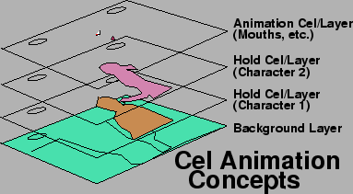**Traditional animation**

Traditional animation is a non-computer based form that enables animation to be made. Each frame being drawn on paper by hand. Once each frame was drawn, it would be put all together. As you can see on the picture, each frame is being drawn and put all together to create one frame. This is a very lengthy process, but computer animations are very quick. This is known as the cel technique. If only one part of the drawing is changed, they would redraw only that part. This is lower-budget animation and it is known as limited animation. This technique was popular and the United Productions of America used it.

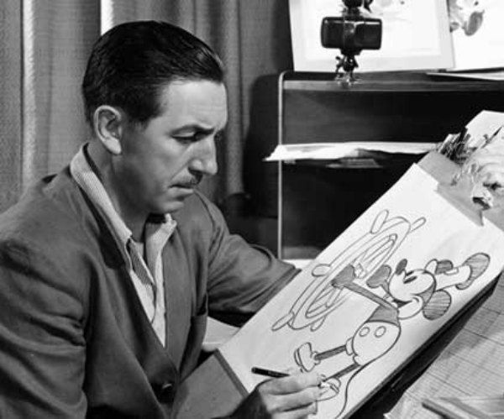**Walt Disney**

Walt Disney was a famous person for his work of animation. He was the co-founder of the Walt Disney Company. He introduced one of his first animation and it was ‘Snow White and the Seven Dwarfs’ in 1937. As you can see, one of the drawings he made.

**How movement is achieved?**

* **Frame by Frame**

[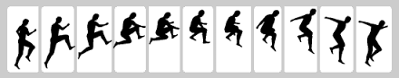](http://www.google.co.uk/url?sa=i&rct=j&q=&esrc=s&source=images&cd=&cad=rja&uact=8&ved=0CAcQjRw&url=http://www.developingwebs.net/flash/frameXframeanimation.php&ei=Z-89Vd6AC4HKaPDUgcgO&bvm=bv.91665533,d.d2s&psig=AFQjCNHs2gLBIkxSn6MmPxcIgC1nXrpW0A&ust=1430208748252753)Frame by Frame is done by each frame being complete. This is complete by one frame complete and manipulating the object with the second frame being complete. This is one of the easiest ways of animation. This shows an example of a person jumping below. If you zoom in to the first two frames. It only tweaks the leg by changing its position.

* **Tweening**

[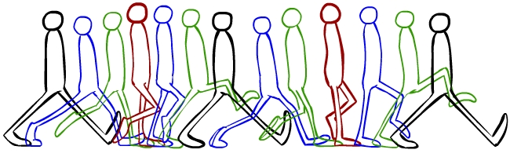](http://anipedia.thebackalleys.com/index.php/Image:Walk_cycle.jpg)Tweening, short for in-betweening, creates two frames similar to each other with movement. The picture shows an example of Tweening. The green and blue are the example of it.

* **Morphing**

[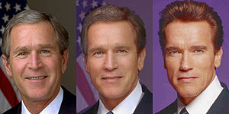](http://en.wikipedia.org/wiki/File:Bush-Arnie-morph.jpg)Morphing is a special technique that is used within pictures. Its original picture is distinguish with its replaced picture. It is easy to spot morphing technique, but to do this, it is very hard. However, it depends how it is done. The example shows how hard it is. It turns George Bush to Arnold Schwarzenegger.

* **Masking**

Masking is a very unique technique that replaces a part of an image with another one. This is a very simple image shown on the right. All they did for this to be masking is put a circle and replace the circle with a dotted blue in it. If the masking was more advanced, it would be hard to spot.

**Reference**

<http://unit31-ryandenton.blogspot.co.uk/2013/10/task-1-p1-explain-different-types-of.html>